COMSATS UNIVERSITY ISLAMABAD LAHORE CAMPUS

Department --> Computer Science

Name : Hafiz Umer Shaban
Roll No : FA23-BCS-056

Devops Mid term Lab

Github Repo Screenshot:

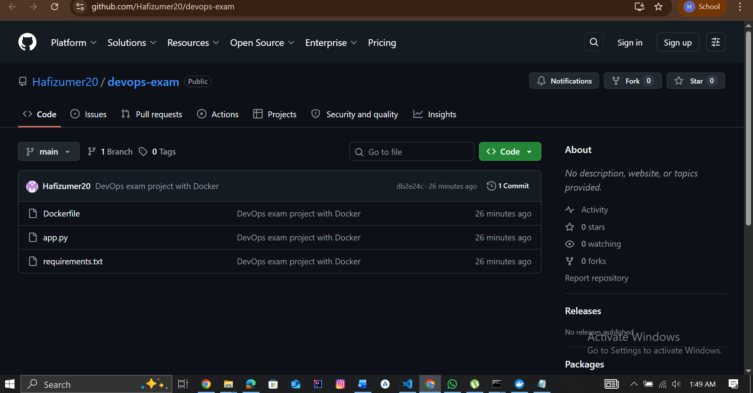
Link: https://github.com/Hafizumer20/devops-exam

Docker Hub ScreenShot:
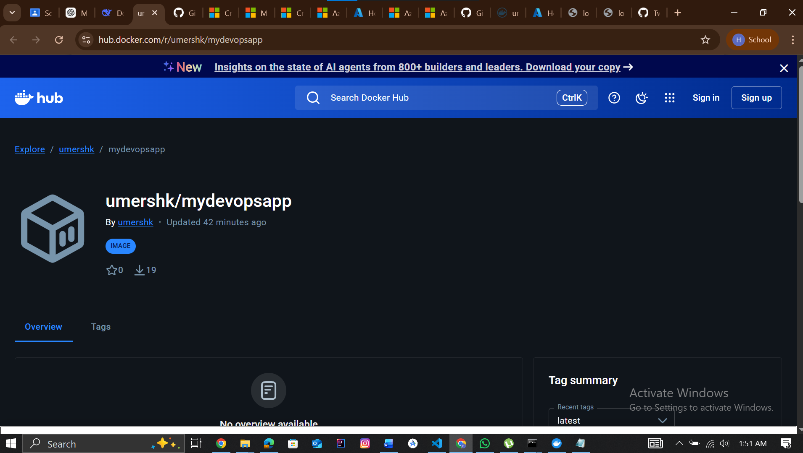
Link : https://hub.docker.com/r/umershk/mydevopsapp

Local Application Running (http://localhost:5000):

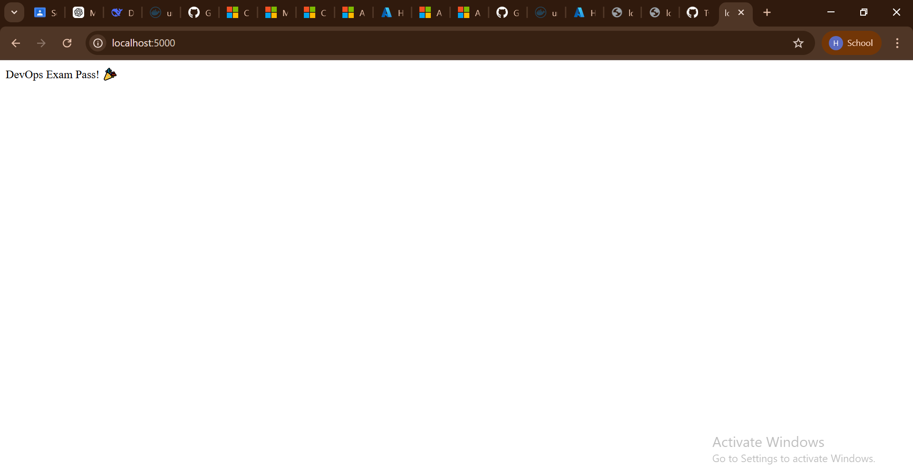
Link : http://localhost:5000

Docker Images (docker images):
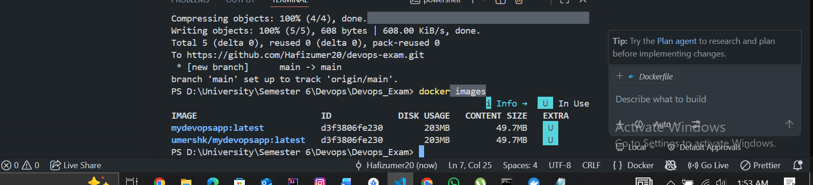
Image Name: mydevopsapp:latest
Image Name: umershk/mydevopsapp:latest
Image ID: d3f3806fe230

app.py Code:
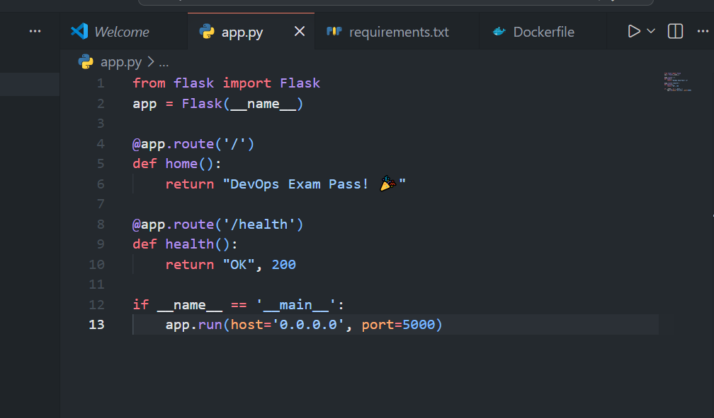

Dockerfile Code:
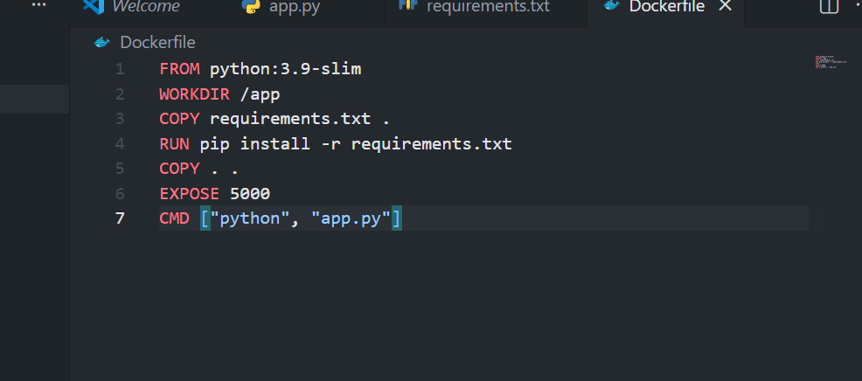

requirements.txt Code:
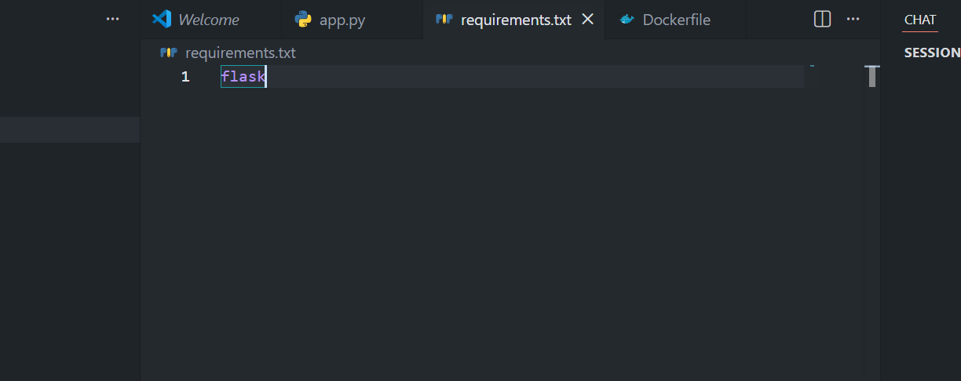

Azure Sign-up Issue (Proof):
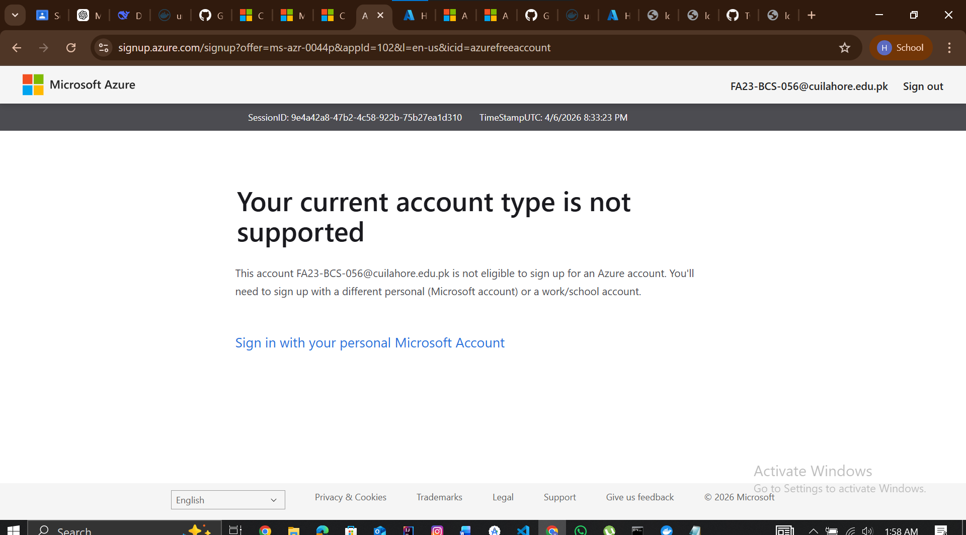

Microsoft account sign-up mein temporary technical issue ki wajah se AKS deploy nahi kar paya. Baaki saara kaam complete hai

Conclusion:
- Application developed successfully (Flask)
- Docker container created and tested
- Docker Hub push completed (umershk/mydevopsapp)
- GitHub upload completed (Hafizumer20/devops-exam)
- All screenshots attached
- Azure AKS pending due to Microsoft account sign-up issue

